**Problem:**

The world’s top pollinator, the Honeybee, faces day to day ailments and hindrances such as changes in temperature, disease, mites, and more. The United States particularly offers a wide range of temperatures from the cold, dry north to the warm, humid south which affects the Honeybee’s survivability and susceptibility to mites and disease.

**Customer Discovery Plan:**

With a wide array of bases, we plan to market our product from the top-down approach. Offering a full suite of products and services from commercial farmers and agribusiness, to the local farmer, beekeeper, and hobbyist. Over the past several weeks, we have inquired and asked various questions to better understand and improve our reach to our clientele.

**Who we are:**

HiveTech Innovations, is a hypothetical company dedicated to preserving and promoting the Honeybee, the world’s most popular pollinator. Without the support and dedication to the honeybee, several of our commodities would no longer be available and the Earth as we know it would be changed forever.

Our CEO: Wes Huneycutt, is an Early Entry M.S Bioinformatics student with two undergraduate degrees of Computer Science and German.

Our CTO: Sabrina Pinard, is an Early Entry M.S Bioinformatics student with an undergraduate degree in Biology.

Our CFO: Catherine Cheedle, is an undergraduate student with a degree in Computer Science concentrating in Bioinformatics.

**Our Product:**

HiveTech Innovations focuses on the Honeybee and its preservation. With this in mind, we have developed a bee proven to be hardier against ever changing temperatures and more resistant to common illness and parasite issues current Honeybees face. Our product comes with a myriad options of services, including subscription plans, packages, and professional support from our company.

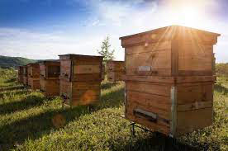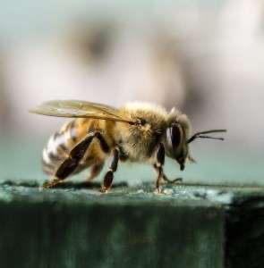

**Timelines:**

Company Structure:

-Jan 2024: Idea created, officers named, HiveTech Innovations born.

-Jan 2024: Product targeted, exploration into use, development and demand made.

-March 2024: Hire first professional apiarist apart of staff

-November 2024: Expand into multiple apiarists, begin broader product development.

-2024: Expand and operate on Research Hives

-Jan 2028: Fully launch products, services.

Financial:

-Jan 2024: Company created, idea explored, development and demand investigated.

-Feb 2024: Pre-Read completed, explored with private investors and asking for 6,000,000 dollars to support start-up cost and ensure at minimum of one-year company continuity.

-March 2024: Open for investors again, with support needed for further continuity and R&D.

-January 2025: Positive ROI and begin to further develop products and deepen interest to prospective populations.

Product Development:

-Jan 2024: Company & Idea explored and created.

-Jan 2024: Target audience/prospective audience identified and product development and appeal begins.

-Feb 2024: Startup cost and R&D cost investigated and presented to private investors

-June 2024: First products field tested, apiarist on board

-Jan 2025: Expansion of Research Hives

-Jan 2028: Open to deployment!

-Jan 2034: North Carolina’s biggest supplier

**Budget:**

HiveTech Innovations will start out by servicing both North and South Carolina with a 150 mile radius from our office. Our costs include monthly labspace rent, employee expenses, scientific instrumentation, CRISPR-CAs9 systems and other items not listed.

Our estimated startup cost for our company would be around 800,000 dollars. We are asking 6,000,000 dollars to ensure our start-up gets off to a steady start. 6,000,000 would secure at a minimum of a two years labspace rent, the ability to sequence and use CRISPR, and explore further product development and quality assurance.

**Executive Summary:**

Our team has rigorously researched and investigated what problems our bees are facing and how some bees are naturally adept to these challenges. For example, we have seen how a russian bee is a bit more resistant against varroa mites, one of our top concerns. These bees form a symbiotic relationship with the mites, thus not having a pestual problem. We have discovered that our customer base is willing to learn more about our process of selectively bred bees and how this bee can ensure the continuation of pollination for generations to come. Our subscription plan on pricing seems to have an effective model, since we offer several different types of perks and benefits to being members of our plan. Our discovery also found that knowledge of how beekeeping works is not wide-known. It is our opinion that as something as crucial as honey bee keeping/pollinator support, these practices and methods should be widely known. We hope to be able to expand knowledge in teaching, resource guides, and public speaking events.

Beekeeping can be for anyone, this profession or hobby is not idealistic to any trait or creed. With a bit of passion, you can help ensure our next generation of pollination and our benefits from such pollination.